Link to git repository.

[Github](https://git.fhict.nl/I509460/individual_assigment_s2.git)

The web application will have the possibilities to allow the users who are using it to be able to order items online – wines, a gift or accessory, which are provided by a wine shop. They can also send their feedback to the admin, who will be responsible for the tracking of the activities, which have been done by the user.

Table of Contents

Homepage: 1

Wines: 1

Events: 1

Blog: 1

About us: 1

Contacts: 2

Gifts: 2

Accessories: 2

Sitemap: 2

Wireframes: 2

Homepage 3

Wines 4

Events 5

Blog 6

About us 7

Contacts 8

Gifts 9

Accessories 10

# Homepage:

The user will be greeted with a page which will show them a menu in a “header.” It will also probably have some pictures which are going to be rotating underneath it so that it keeps the attention of the user. There will be photos in the middle, which are links towards the other pages of the project.

# Wines:

Here the system will show different wines which can be bought by the users. The products can also be sorted by different criteria – price, kind, country where it has been produced or the title of the bottle

# Events:

Here the system provides information about different events which have been organized by the owners of the shops. It will mainly contain text and pictures

# Blog:

It will be similar to the “Events” section, but it will contain things which are connected with other parts of the company

# About us:

It will contain different kinds of information about the company, for example the history of it, a map which shows where it is located and some pictures

# Contacts:

Here the users of the web application can get information on how they can contact the company or leave some form of feedback

# Gifts:

The shop will provide with various kinds of bundles which are suitable for gifts. The user can decide which one to buy from them.

# Accessories:

Accessories can also be bought from the shop by the user.

# Sitemap:

# Wireframes:

## Homepage

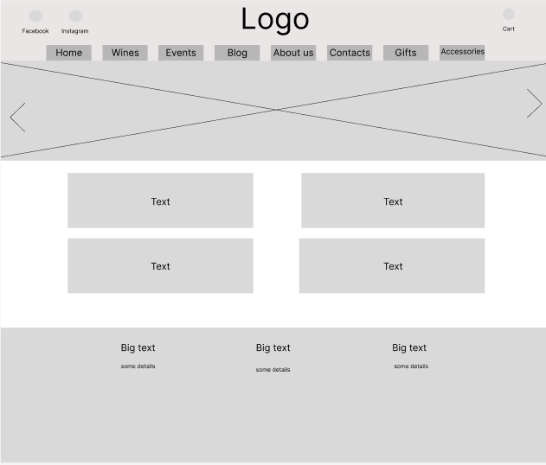

## Wines

## Events

## Blog

## About us

## Contacts

## Gifts

## Accessories

